CLOUD ANALYTICAL
SOLUTION ARCHITECTURE

Version 1.0
for Gladpharm

Contents
1. Introduction 3
1.1. Purpose 3
1.2. Definitions and abbreviations 3
2. Solution architecture 4
2.1. Scope 4
2.2. Business requirements 4
2.3. Success criteria 5
2.4. Data sources 5
2.5. Networking 5
2.6. Component architecture 6
2.7. Identities 7
2.8. Storage 8
2.8.1. Microsoft Fabric lakehouse 8
2.9. Processing 8
2.9.1. DWH data actualization orchestration 8
2.9.2. DWH bronze layer ERP data actualization 9
2.9.3. Microsoft Fabric warehouse gold layer entities actualization 10
2.9.4. Microsoft Power BI datasets information retrieving 11
2.9.5. Microsoft Power BI datasets refreshing 11
2.10. Results 12
2.10.1. Key results 12
3. Annexes 14
3.1. Microsoft Azure DevOps organizations 14
3.2. Microsoft Azure DevOps projects 14
3.3. Microsoft Azure DevOps repositories 14
3.4. Logical environments 15
3.5. Microsoft Azure subscriptions 15
3.6. Microsoft Azure resource groups 15
3.7. Microsoft Azure app registrations 15
3.8. Microsoft Azure security groups 16
3.9. Microsoft Fabric workspaces 17

Introduction

Purpose
This document is a main source of information about cloud analytical solution, which was made by Kyivstar for Gladpharm. It reflects the implementation results, describes solution architecture design and key drivers, such as data sources and their types, business requirements etc. It also contains information about created cloud-resources and other.

Definitions and abbreviations
# | Term | Description
1 | DWH | Data Warehouse
2 | HTTPS | Hyper Text Transfer Protocol Secure
3 | REST | Representational State Transfer
4 | API | Application Programming Interface
5 | URI | Uniform Resource Identifier
6 | OData | Open Data Protocol
7 | ETL | Extract, Transform, Load
8 | ELT | Extract, Load, Transform
9 | BI | Business Intelligence
10 | IaC | Infrastructure as Code

Solution architecture

Scope
The scope of the solution is to automate an isolated end-to-end business process, which is already implemented by the client, using manual operations. The implementation expects the following:
- Data sources: ERP (only)
- Output: Microsoft Azure/Microsoft Fabric infrastructure with ETL/ELT components and data for reporting within DWH; Microsoft Power BI budget report with an agreed structure
- Processes tested: data ingestion, transformation, reporting
- Evaluated: data accuracy, report responsiveness, refresh speed, user interactivity
The following picture displays the high-level overview of the existing business process, which should be automated during the implementation:
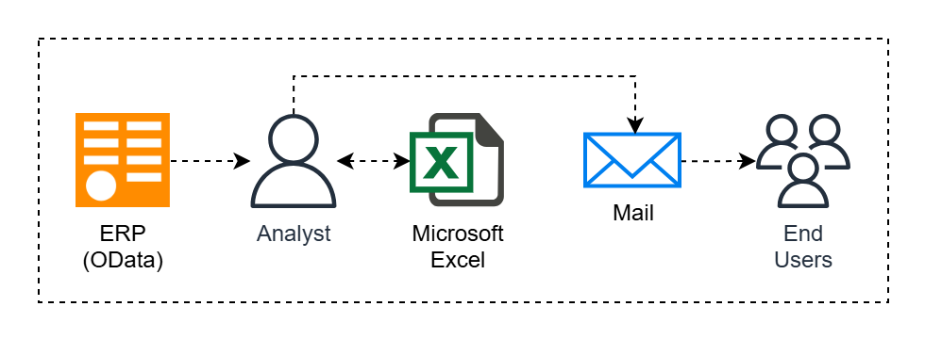

Business requirements
Reproduce the existing Microsoft Excel report ''Бюджет наступного року по ЦФВ'' within Microsoft Fabric and Microsoft Power BI. Data from ERP used for budgeting and financial reporting, along with reference catalogs (budget items, cost centers and organizational units) should be ingested, transformed and aggregated automatically, replacing manual data preparation and consolidation.
The resulting Microsoft Power BI dashboard should replicate the structure of the current Microsoft Excel report, allowing filtering by organization, CFR, cost center, employee and period, with export options for management review.
The Azure DWH objects should be fully reloaded during every ingestion.
The data ingestion process should match the following schedule: 1 time per day from January to September; 1 time per working hours from October to December.

Success criteria
The solution will be considered successful, if the Microsoft Fabric will enable the full automation of the report, which was previously created manually in Microsoft Excel, with daily or on-demand refreshes through Microsoft Fabric data pipelines, and delivery of an interactive Microsoft Power BI report, that replicates the existing structure, while significantly reducing manual effort and demonstrating readiness for scalable, governed analytics within Gladpharm.

Data sources
# | Data source name | Data source type | Data source details (URI, connection string etc.) | Data source access mechanism | Data source description
1 | ERP | REST API | - URI: https://api-gateway.kusum.ua/ | HTTPS request Authorization header with defined Bearer token | ERP system, which is actually OData under the hood, but is accessible via API Gateway and acts like a REST API. Contains financial data, information about users etc.

Networking
The solution doesn’t require any specific networking components to access the data source, because ERP has no network access restrictions and available through HTTPS requests with provided valid Bearer token.
The solution’ networking is focused mainly on Terraform backend isolation, to protect the access to the Azure storage account from the Internet, because this Azure storage account contains containers with Terraform states files, which are used for IaC.

Component architecture
The following picture displays the high-level overview of Microsoft Azure/Microsoft Fabric components, which are involved in the solution implementation:
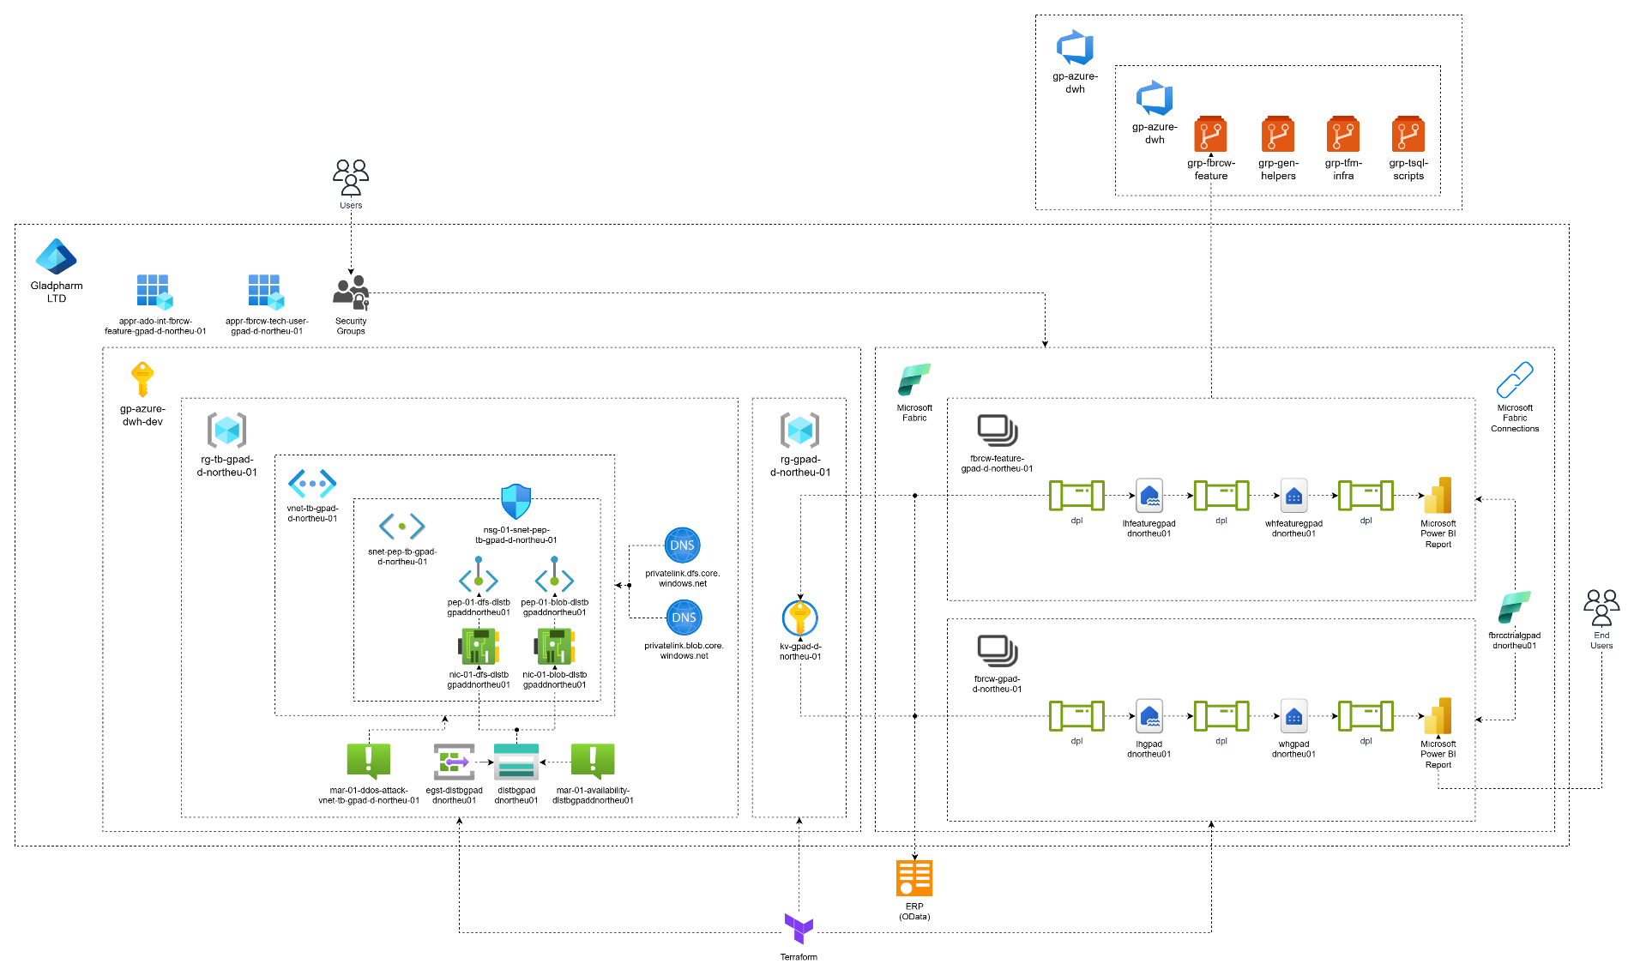

The following Microsoft Azure/Microsoft Fabric components were provisioned in scope of the solution (look ''Annexes'' section to find detail information):
- Microsoft Azure DevOps organization
- Microsoft Azure DevOps project
- Microsoft Azure Git repositories
- Microsoft Azure app registrations
- Microsoft Azure security groups
- Microsoft Azure subscription
- Microsoft Azure resource groups
- Microsoft Azure virtual network
- Microsoft Azure virtual network subnet
- Microsoft Azure private endpoints
- Microsoft Azure storage account
- Microsoft Azure key vault
- Microsoft Fabric trial capacity
- Microsoft Fabric connections
- Microsoft Fabric workspaces
- Microsoft Fabric lakehouses
- Microsoft Fabric warehouses
- Microsoft Fabric data pipelines

Identities
The solution utilizes Microsoft Entra ID identities:
# | Use-case | Description
1 | Access to Azure subscription for infrastructure deployment | Infrastructure deployment access is provided by creating/inviting user-related Microsoft Entra ID users, with granting an appropriate RBAC permissions to them (Owner with RBAC permissions)
2 | Access to Microsoft Azure key vault secrets from Microsoft Fabric items | The separate Microsoft Azure app registration (Microsoft Fabric technical user) with appropriate RBAC permissions is created to be used in Microsoft Fabric connection (Key Vault Secrets User on specific Azure key vault secrets)
3 | Microsoft Fabric workspaces users’ access | The separate Microsoft Azure security groups are created, with granted appropriate Microsoft Fabric workspaces roles (Admin, Member, Contributor, Viewer). To gain the access users should be added to these security groups
4 | Microsoft Fabric connections users’ access | The separate Microsoft Azure security groups are created, with granted appropriate Microsoft Fabric connections roles (Owner, User with resharing, User). To gain the access users should be added to these security groups
5 | Access to Microsoft Fabric child data pipelines/Microsoft Power BI REST from Microsoft Fabric data pipelines | The set of Microsoft Fabric connections are created, which utilize Microsoft Fabric technical user access (Microsoft Fabric technical user is a Microsoft Azure app registration with Microsoft Fabric workspace Contributor role)
6 | Access to Microsoft Fabric warehouse from Microsoft Power BI report | The separate Microsoft Fabric connection is created, which utilizes Microsoft Fabric technical user access (Microsoft Fabric technical user is a Microsoft Azure app registration with Microsoft Fabric workspace Contributor role)

Storage

Microsoft Fabric lakehouse
Raw data snapshots are stored in the Microsoft Fabric lakehouse as parquet files during every data ingestion process.
The parquet files path has the following structure:
files/data/snapshots/<source_system_name>/<source_system_schema_name>/<entity_name>/tech_business_year=<YYYY>/tech_business_month=<MM>/tech_business_day=<DD>/tech_business_hour=<HH>/tech_processing_date_time:<YYYY-MM-DD_HH-MM-SS>__tech_executor_run_id:<UUID>__tech_processor_run_id:<UUID>.parquet

Processing

DWH data actualization orchestration
Orchestration process utilizes the Microsoft Fabric data pipeline with scheduled trigger. This pipeline is a main pipeline, which contains information about entities, which should be ingested and loaded to the Microsoft Fabric warehouse stage/bronze layers, which entities should be actualized on the Microsoft Fabric warehouse gold layer, and which Microsoft Power BI datasets should be refreshed after the Microsoft Fabric warehouse actualization.
The orchestration pipeline has predefined default input parameters, which values are aligned with the solution requirements.
The orchestration pipeline mainly uses ''Invoke Pipeline” activity to trigger the child pipelines, which contain additional processing logic, but it also contains other activities to make logic more flexible.
The following picture displays the orchestration data pipeline activities flow:
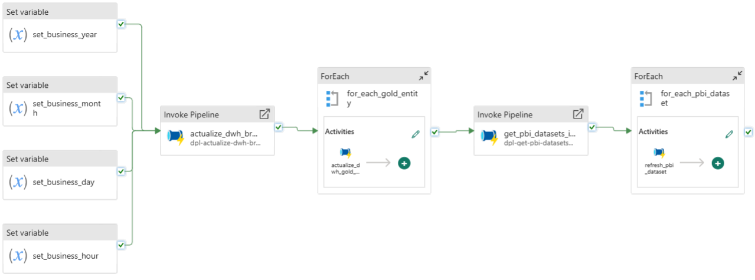
The data pipeline has the following steps:
- Business period variables defining, which will be passed to invoked child data pipelines
- DWH bronze layer ERP data actualization (includes Microsoft Fabric lakehouse and Microsoft Fabric warehouses data actualization)
- Microsoft Fabric warehouse gold layer entities actualization
- Microsoft Power BI datasets information retrieving
- Required Microsoft Power BI datasets refreshing

DWH bronze layer ERP data actualization
The actualization process is implemented, using Microsoft Fabric data pipelines and has different layers, which are logically tied to the different data pipelines. The data pipelines are invoked by orchestration data pipeline and have no configured triggers.
The data pipelines input parameters have no predefined values and are filled with appropriate values from the data pipeline-invoker (orchestration data pipeline).
The actualization process contains of two data pipelines:
- General ERP data actualization data pipeline
- ERP entity data actualization data pipeline (invoked by general ERP data actualization data pipeline)
The following picture displays the general ERP data actualization data pipeline activities flow:
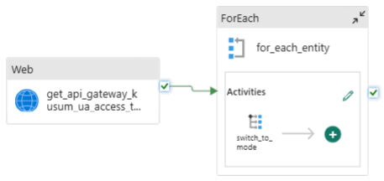
The data pipeline has the following steps:
- ERP REST API access token retrieving, which will be passed to invoked child data pipelines
- ERP entity data actualization
The following picture displays the ERP entity data actualization data pipeline activities flow:
The data pipeline has the following steps:
- ERP entity data first row retrieving, which will be used to dynamically build copy activity mapping and Microsoft Fabric warehouse stage layer table structure
- Preparation of copy activity mapping and DWH stage layer table DDL
- ERP entity data snapshot loading to the Microsoft Fabric lakehouse
- Loading of the latest data snapshot from Microsoft fabric lakehouse to the Microsoft Fabric warehouse stage layer
- Loading the Microsoft Fabric warehouse stage layer data to the Microsoft Fabric warehouse bronze layer

Microsoft Fabric warehouse gold layer entities actualization
The actualization process is implemented, using Microsoft Fabric data pipeline, which is invoked by orchestration data pipeline and has no configured triggers.
The data pipeline input parameters have no predefined values and are filled with appropriate values from data pipeline-invoker (orchestration data pipeline).
The following picture displays the Microsoft Fabric warehouse gold layer entities actualization data pipeline activities flow:
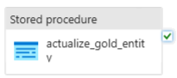
The data pipeline has the following steps:
- Microsoft Fabric warehouse gold layer entity actualization

Microsoft Power BI datasets information retrieving
The retrieving process is implemented, using Microsoft Fabric data pipeline, which is invoked by orchestration data pipeline and has no configured triggers.
The data pipeline has no input parameters.
The following picture displays the Microsoft Power BI datasets information retrieving data pipeline activities flow:
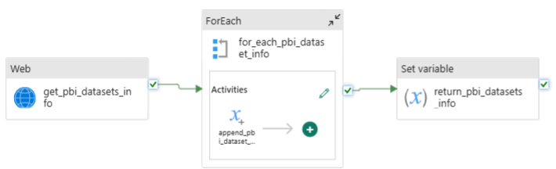
The data pipeline has the following steps:
- Current Microsoft Fabric workspace Microsoft Power BI datasets information retrieving
- Retrieved Microsoft Power BI datasets information preparation
- Returning of the prepared Microsoft Power BI datasets information

Microsoft Power BI datasets refreshing
The refreshing process is implemented, using Microsoft Fabric data pipeline, which is invoked by orchestration data pipeline and has no configured triggers.
The data pipeline input parameters have no predefined values and are filled with appropriate values from data pipeline-invoker (orchestration data pipeline).
The following picture displays the Microsoft Power BI dataset refreshing data pipeline activities flow:
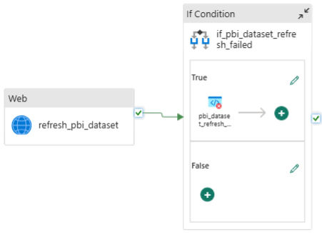
The data pipeline has the following steps:
- Microsoft Power BI dataset refreshing
- Microsoft Power BI dataset refresh error raising

Results
The following table describes the performance of the processes, which were implemented in scope of the solution:
# | Step description | Expected duration, minutes | Average duration, minutes | Result
1 | DWH bronze layer ERP data actualization | Less than 15 | 6 | Passed
2 | DWH gold layer data actualization | Less than 5 | 1 | Passed
3 | Microsoft Power BI report refreshing | Less than 5 | 1 | Passed
The above results prove the performance of the developed solution and have end-to-end processing time less than 10 minutes.

Key results
The described business process was successfully automated.
Comparison between existing and new solution didn't find any breaks.
End-to-end performance is in bounds of requirements.
Microsoft Power BI report refreshes automatically after the DWH scheduled data processing completion.
The access model to the Microsoft Fabric items, including Microsoft Fabric data pipelines and Microsoft Power BI report, was implemented via Microsoft Azure security groups, which allows end users to trigger the end-to-end process on-demand.
All artefacts, which were created during the solution implementation, was committed to the appropriate Git repositories.

Annexes

Microsoft Azure DevOps organizations
# | Microsoft Azure DevOps organization name | Microsoft Azure DevOps organization description
1 | gp-azure-dwh | The Azure DevOps organization, which contains resources, related to Azure DWH project

Microsoft Azure DevOps projects
# | Microsoft Azure DevOps organization name | Microsoft Azure DevOps project name | Microsoft Azure DevOps project description
1 | gp-azure-dwh | gp-azure-dwh | The Azure DevOps project, which contains resources, related to Azure DWH project

Microsoft Azure DevOps repositories
# | Microsoft Azure DevOps project name | Microsoft Azure DevOps repository name | Microsoft Azure DevOps repository description
1 | gp-azure-dwh | grp-fbrcw-feature | The Azure DevOps Git repository, which is used for DEV-environment Microsoft Fabric feature workspace Azure DevOps integration (contains source code for data pipelines, warehouses etc.)
2 | gp-azure-dwh | grp-gen-helpers | The Azure DevOps Git repository, which contains source code for custom helpers (for example – Microsoft Fabric items tokenizer)
3 | gp-azure-dwh | grp-tfm-infra | The Azure DevOps Git repository, which contains Terraform code, that is used to implement IaC principles
4 | gp-azure-dwh | grp-tsql-scripts | The Azure DevOps Git repository, which contains T-SQL scripts for Microsoft Fabric warehouse etc. (schemas, procedures, views, tables etc.)

Logical environments
# | Logical environment name | Logical environment description
1 | DEV | The environment, which is mainly used by developers to implement new/change existing features

Microsoft Azure subscriptions
# | Logical environment name | Microsoft Azure subscription name | Microsoft Azure subscription description
1 | DEV | gp-azure-dwh-dev | The subscription, which contains resources for Terraform backend, Azure DWH etc.

Microsoft Azure resource groups
# | Microsoft Azure subscription name | Microsoft Azure resource group name | Microsoft Azure resource group description
1 | gp-azure-dwh-dev | rg-tb-gpad-d-northeu-01 | The resource group, which contains Terraform backend resources
2 | gp-azure-dwh-dev | rg-gpad-d-northeu-01 | The resource group, which contains Azure DWH resources

Microsoft Azure app registrations
# | Logical environment name | Microsoft Azure app registration name | Microsoft Azure app registration description
1 | DEV | appr-ado-int-fbrcw-feature-gpad-d-northeu-01 | The app registration, which is used for Microsoft Fabric feature workspace Azure DevOps integration
2 | DEV | appr-fbrcw-tech-user-gpad-d-northeu-01 | The app registration, which is used as a technical user in Microsoft Fabric integrations

Microsoft Azure security groups
# | Logical environment name | Microsoft Azure security group name | Microsoft Azure security group description
1 | DEV | sg-fbrcw-feature-adm-gpad-d-northeu-01 | The security group, which is used to grant admin access to Microsoft Fabric feature workspace
2 | DEV | sg-fbrcw-feature-mem-gpad-d-northeu-01 | The security group, which is used to grant member access to Microsoft Fabric feature workspace
3 | DEV | sg-fbrcw-feature-cnt-gpad-d-northeu-01 | The security group, which is used to grant contributor access to Microsoft Fabric feature workspace
4 | DEV | sg-fbrcw-feature-view-gpad-d-northeu-01 | The security group, which is used to grant viewer access to Microsoft Fabric feature workspace
5 | DEV | sg-fbrcw-adm-gpad-d-northeu-01 | The security group, which is used to grant admin access to Microsoft Fabric workspace
6 | DEV | sg-fbrcw-mem-gpad-d-northeu-01 | The security group, which is used to grant member access to Microsoft Fabric workspace
7 | DEV | sg-fbrcw-cnt-gpad-d-northeu-01 | The security group, which is used to grant contributor access to Microsoft Fabric workspace
8 | DEV | sg-fbrcw-view-gpad-d-northeu-01 | The security group, which is used to grant viewer access to Microsoft Fabric workspace
9 | DEV | sg-fbrccon-feature-owner-gpad-d-northeu-01 | The security group, which is used to grant owner access to Microsoft Fabric feature connections
10 | DEV | sg-fbrccon-feature-user-wr-gpad-d-northeu-01 | The security group, which is used to grant user with resharing access to Microsoft Fabric feature connections
11 | DEV | sg-fbrccon-feature-user-gpad-d-northeu-01 | The security group, which is used to grant user access to Microsoft Fabric feature connections
12 | DEV | sg-fbrccon-owner-gpad-d-northeu-01 | The security group, which is used to grant owner access to Microsoft Fabric connections
13 | DEV | sg-fbrccon-user-wr-gpad-d-northeu-01 | The security group, which is used to grant user with resharing access to Microsoft Fabric connections
14 | DEV | sg-fbrccon-user-gpad-d-northeu-01 | The security group, which is used to grant user access to Microsoft Fabric connections

Microsoft Fabric workspaces
# | Logical environment name | Microsoft Fabric workspace name | Microsoft Fabric workspace description
1 | DEV | fbrcw-feature-gpad-d-northeu-01 | The Microsoft Fabric feature workspace, which is used by developers to manually implement new/change existing features. This workspace has an integration with Azure DevOps to save the latest committed workspace state, which will act as restore point in case, if something will destroy the existing infrastructure
2 | DEV | fbrcw-gpad-d-northeu-01 | The Microsoft Fabric workspace, which is used by developers to automate the manually implemented feature workspace items, using Terraform/PowerShell etc. This workspace items should be maintained as IaC

